East African Regional Training Course on Operation and Maintenance of Most Utilized Micro-Grid Technologies and Data Management

Micro Grid Academy Modules 5 & 6

Concept Note and Agenda
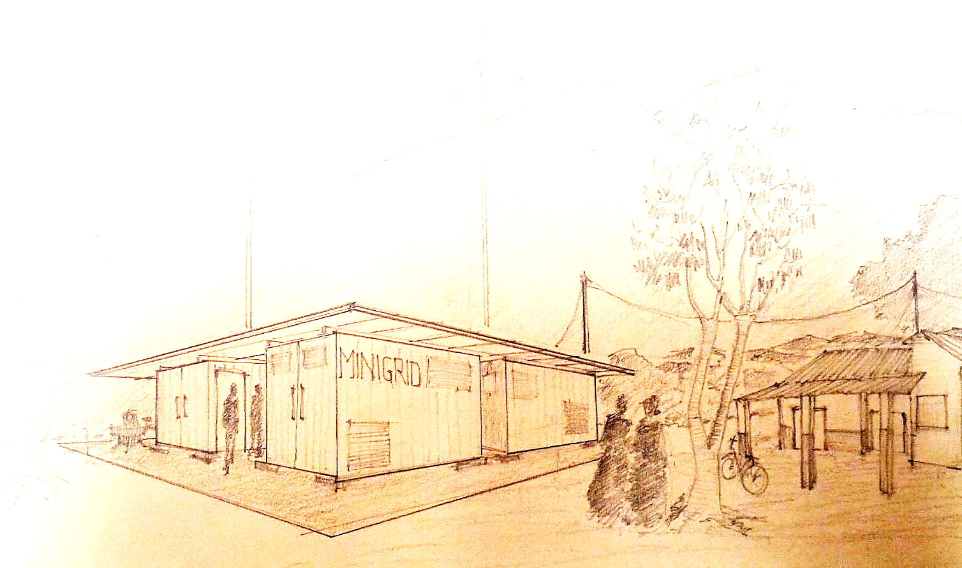

15-24 January 2019,
Nairobi, Kenya

- INTRODUCTION AND CONTEXT

The provision of affordable, reliable, and sustainable energy is essential for the development of sustainable economies, as it advances and strengthens productive capacities that promote socio-economic development in an environmentally sound manner. However, all the East African Community (EAC) partner states face significant energy challenges. Large proportion of the population of the EAC region remains without access to modern energy services, and progress in expanding electricity access has lagged behind population growth. Although there has been some progress in scaling up access to modern energy in the EAC region, electricity access in region is still just about 30%. A lot still has to be done in order to achieve electricity for all by 2030, as pert the aspirations expressed in the Sustainable Development Goals (Goal#7).
Micro-grid (MG) is one of the most viable options for generation capacity increase in Africa to solve raising urban and rural electricity needs. Taking advantage of the readily available solar radiation, min-hydro and wind potentials, in the application of MG can solve the unreliable and epileptic energy the East African region. Electricity from microgrids can support new businesses in a village generating economic development. In fact, the EAC region has several operational small hydropower plants based on solar photovoltaic, minihydros and other renewable energy technologies.
Despite some clear advantages of private sector participation in electrification efforts, there are several challenges that must be overcome to make these projects attractive to potential investors and project developers. The challenges include security of revenue streams, long-term risks and policy certainty, regulatory transparency and complexity, as well as practical challenges relating to local organizational structures and technical skills for operation and management of micro-grids.

- OBJECTIVES OF THE MICRO-GRID ACADEMY

To build the technical capacity for management of Micro-Grid Academy (MGA) for East-Africa has been set up at Institute of Energy Studies, Nairobi, Kenya.
The specific objective of the MGA is to conduct capacity building activities upon energy access and decentralized renewable energy solutions directed towards East-African young technicians, managers and engineers, supported by a real 20-40 kW mini-grid system installed on-site. This will contribute to emhancement of access to energy in rural communities and foster local enterprise and job creation.
- MODULE 5 & 6 CONTENT

Module 5&6 will focus on Operation & Maintenance of Most utilized MG Technologies and Data Management. It will provide theoretical knowledge on devices, usage of specific software as well as hands-on learning in labs, giving deeper concepts on generation and distribution technologies, remote metering and data analysis. The topics to be covered include:
- Hybrid mini-grid systems
- Case study: Wolisso system design, procurement and construction, lessons learnd, etc.
- Commissioning of the plant: test, safety requirements, turnover
- Operation and maintenance of renewable plants
- Remote control and data analysis
- 2 site visits: Talek and Kitonyoni
- Half-day to the Schneider factory

- EXPECTED OUTCOMES

- It is envisaged that the participants will acquire sufficient knowledge on operation, maintenance and management of MGs and will be able to run their MGs based on systematic procedures with good data management and ensuring sustainability.

- Improved planning and operation of MGs, thus contributing to an increased and improved access to modern energy services.

- Improvement in troubleshooting and maintenance of MGs so as to reduce downtimes, thus contributing to an expanded as well as an improved and more stable power supply.

- CERTIFICATES
Upon successful completion, the participants will receive certificates of attendance.

- PARTICIPANTS QUALIFICATION AND PREPARATION

The course is open to a maximum of 50 participants from the EAC Partner States.
Requirements:
- Applicants in the energy field will be given priority.
- Applicants must be able to speak and read English.
- Applicants from all countries can apply to participate to the MGA. However, applicants from Sub-Saharan countries and particularly from East African Community (EAC) will be given priority.

The participants shall be. They must have background in technical areas, like mechanics, electricians, etc.
In order to fully benefit from the programme, participants are encouraged to bring along information about operation and maintenance issues related to their past and current works that can be shared with colleagues.

- REGISTRATION PROCESS

Applicants should complete the application form and send their CV by E-Mail to Prof. Andrea Micangeli (andrea.micangeli@uniroma1.it) and copy info@eacreee.org, Andrea De Silvestri (andrea.desilvestri@res4africa.org), Carol Mwendwa (mwendwacarol.avsi@gmail.com) by 20th December 2018. The applications must be endorsed by the employer. Nominations received after deadline will not be considered.

- FINANCIAL ARRANGEMENTS AND LIABILITIES

There will be no tuition fees charged. However, the costs of travel and accommodation during the training course will be covered by each participant or their employers. The organizers will provide course materials, modest lunch and coffee breaks during the course.
It will be the responsibility of each participant to make his/her own reservation and arrangements for commuting between the hotel and the venue. The participants should get in touch with the local organizer, Carol Mwendwa (mwendwacarol.avsi@gmail.com), for assistance in booking the accommodation.

- LIABILITIES OF DAMAGES

The organizers of the course do not accept liability for the payment of any cost or compensation that may arise from damage to or loss of personal property, or from illness, injury, disability or death of a participant while he/she is traveling to and from or attending the course, and it is clearly understood that each participants (or sponsor), undertakes responsibility for such coverage. The participants would be well advised to take out insurance against these risks.

- THE ORGANIZERS AND PARTNERS

The course is jointly organized by Enel Green Power (EGP), the East African Centre of Excellence for Renewable Energy and Efficiency (EACREEE), Renewable Energy Solution for Africa (RES4AFRICA), AVSI Foundation, Kenya Power and Lighting Company (KPLC), Strathmore University, St. Kizito Vocational Training Institute and supported by Enel Foundation.
Local Organizer (Contact Person) is:
Carol Mwendwa
AVSI Foundation
E-mail: mwendwacarol.avsi@gmail.com
Tel: +254 721 851 957

Tentative Course Schedule

Date | Location | Time | Activity/Topic | Teacher Affliliations
15/01/2019  Tuesday | KPLC | 14:00 – 15:30 | Presentation: MGA, RES4Africa and the 5th Module | KPLC, EACREE (tbc), Res4Africa,  Strathmore, AVSI
 |  | 15:30 – 17:00 | Class: O&M best practices | AMDA (tbc) (and others)
 |  | 17:00 – 17:15 | Lab Visit: MGA plant site and Solar Potabilization Devices | KPLC
16/01/2019  Wednesday | KPLC | 09:30 – 11:00 | Class: O&M - from Commissioning to Procedures in Wolisso Project | EGP (MS)
 |  | 11:00 – 12:30 | Class: Operation of MG | EGP (MS)
 |  | 14:00 – 17:00 | Class: Maintenance | EGP (MS)
 |  | 17:00– 17:15 | Debriefing
17/01/2019  Thursday | Strathmore  SERC | 09:30 – 10:30 | Class: Real data analysis and monitoring | EGP (MS)
 |  | 10:30 – 11:30 | Class: Energy and storage systems O&M | EGP (MS)
 |  | 11:30 – 12:30 | Lab Visit: SERC Facilities | Equatorial Energy (tbc)
 |  | 14:00 – 15:30 | Class: O&M Plant Development | Universities
 |  | 15:30 – 17:00 | Class: Troubleshooting | Equatorial Energy (tbc)
 |  | 17:00– 17:15 | Debriefing
18/01/2019  Friday | St.Kizito | 09:30 – 11:30 | Class: Safety Procedures | EGP (MS)
 |  | 11:30 – 13:30 | Class: Plant Sizing - Long-term evolution of load-generation and distribution | Universities
 |  | 14:00 – 14:45 | Lab Visit: Programmable Logic Controllers (PLCs) and automation | St.Kizito
 |  | 16:00 | Departure for field visit
19/01/2019  Saturday | Field Visit  Talek | 09:30 – 17:30 | Training on field: Real life O&M and Data Management | Universities
 |  |  | Class: Solar modules in operation | Power Gen (tbc)
 |  |  | Class: Degradation of the components | RES4Africa
20/01/2019  Sunday | Field Visit  Talek | 09:30 – 17:30 | Training on field: Real life O&M and Data Management | Talek Power
 |  |  | Class: Design and Management toolkit study for Microgrid | Power Gen / R4A
21/01/2019  Monday | Strathmore SERC | 09:30 – 10:00 | Presentation: MGA, RES4Africa and the 6th Module | Res4Africa, Strathmore, KPLC, EACREE (tbc)
 |  | 10:00 – 12:30 | Class: TEMPO – Homer - Off Sets and other Softwares | Universities
 |  | 14:00 –16:00 | Class: Commissioning | EGP (SC)
 |  | 16:00 – 17:00 | Class: Safety Procedures | EGP (SC)
 |  | 17:00 – 17:15 | Debriefing
22/01/2019  Tuesday | Strathmore SERC | 09:30 – 12:30 | Class: Commissioning | EGP (SC)
 | Schneider | 14:00 – 17:00 | Lab: Remote monitoring and control of MGs | Schneider (tbc)
 |  | 17:00– 17:15 | Debriefing
23/01/2019  Wednesday | Field Visit Kitonyoni | 07:00 | Departure for field visit
 |  | 10:00 – 17:00 | Class: Data acquisition, analysis and transmission | Southampton University (tbc)
 |  |  | Class: Community interaction | E4Impact (tbc)
 |  |  | Class: Preliminary studies for the base line in MG Design | R4A (and others)
24/01/2019  Thursday |  | 09:30 – 10:30 | Class: Employment opportunities | Agency (tbc)
 | KPLC | 10:30 – 12:30 | Lab: MG O&M Design | KPLC (and others)
 | Ruaraka | 14:00 – 17:00 | Design Presentations | AVSI
 |  | 17:00– 17:15 | Final Ceremony | MGA Partners

